

COREP Taxonomyies
Technical Documentation dated 2007-02-06
This version:
COREP – FINREP Documentation-2007-02-06.doc

Abstract
This document describes the COREP and FINREP reporting frameworks with their respective taxonomies, which have been created for the Committee of European Banking Supervisors (CEBS) for credit institutions and investment firms in the European Union. These taxonomies have been developed using the computer open source standard XBRL (eXtensible Business Reporting Language) for interactive reporting. COREP is the computerized representation of the CEBS Common Solvency Reporting Framework, while FINREP is for the Standardized Financial Reporting Framework.

Status
This is a Technical Documentation whose circulation is restricted to members of the COREP, FINREP and XBRL working groups.

Table of Contents
Abstract i
Status i
Table of Contents ii
1 Introduction 4
1.1 Authority 5
1.2 Goals of this document 5
1.3 Organisation of this document 5
1.4 Terminology and document conventions 6
2 Business Requirements 6
2.1 Flexible Framework/Extensibility 6
2.2 Stability 6
2.3 Completed within specified timeframe 6
2.4 Ease of implementation 6
3 Summary of Known Limitations/Constraints 6
4 Introduction to XBRL multidimensionality 6
5 Overview of the COREP Taxonomy 6
5.1 Content 6
5.2 Structure 6
5.2.1 COREP Data Model 6
5.2.2 Primary and Dimensional Taxonomies 6
5.2.3 Common Primary Taxonomies introduced in version 1.2 6
5.2.4 Template Taxonomy 6
5.2.5 Organisation of Linkbases 6
5.2.6 Creating instance documents 6
5.3 Naming Conventions 6
5.4 Taxonomy Testing 6
6 Overview of the FINREP Taxonomy 6
6.1 Content 6
6.2 Structure 6
6.2.1 FINREP Data Model 6
6.2.2 Primary and Dimensional Taxonomies 6
6.2.3 Template Taxonomy 6
6.2.4 Creating instance documents 6
6.3 Naming Conventions 6
6.4 Taxonomy Testing 6
7 National Taxonomy Customisation COREP - FINREP 6
7.1 National extension structure 6
7.2 Categorisation of national taxonomy extensions 6
7.3 Creating extension taxonomy 6
7.4 Customisation of labels 6
7.5 Customisation of references 6
7.6 Customisation of the template structure 6
7.6.1 Adding or removing columns and rows 6
7.6.2 Reordering the hierarchical structure of a template 6
7.6.3 Restricting cells from being reported 6
7.6.4 Removing dimensions from a template 6
7.6.5 Providing choices among dimensions 6
7.7 Customisation of calculations 6
8 Changes and Updates 6
8.1 COREP Taxonomy Versions 6
8.1.1 COREP Taxonomy 1.0.1 6
8.1.2 COREP Taxonomy 1.2 6
8.1.3 COREP Taxonomy 1.2.1 6
8.1.4 COREP Taxonomy 1.2.2 6
8.1.5 COREP Taxonomy 1.2.3 6
Open Issues 6
Appendix A. References (non-normative) 6
Appendix B. Intellectual Property Status (non-normative) 6
Appendix C. Acknowledgments (non-normative) 6
Appendix D. Document history 6
Appendix E. Approval process (non-normative) 6

Introduction
The Committee of European Banking Supervisors (CEBS) has finalised its common reporting framework COREP (COmmon REPorting) for the new solvency ratio for credit institutions and investment firms (hereinafter referred to as “reporting entities”) under the European Union (EU) capital requirements regime and has also published guidelines establishing a standardised financial reporting framework (FINREP) for credit institutions operating in the EU.
The COREP work is primarily focused on regulatory own funds and the Basel II Pillar I capital requirements pertaining to credit risk, operational risk and market risk. The aim is to reduce the reporting burden on reporting entities and encourage a level playing field across Europe. Please visit www.c-ebs.org and www.corep.info for details. The COREP project team has completed a harmonised business model for the European solvency reporting requirements, which is published in 18 templates. These templates were finalised as guidelines for a common reporting framework (COREP) on January 13, 2006 and they will probably not be changed for several months.
The FINREP framework, based on 40 templates, will enable credit institutions to use the same standardised data formats and data definitions for prudential reporting in all countries where the framework will be adopted. CEBS believes that this will reduce the reporting burden for credit institutions that operate cross-border, and lower barriers to the development of an efficient internal market in financial services. For extra reading please visit www.c-ebs.org and the project web site at www.finrep.info .
CEBS also intends to provide XBRL taxonomies for the national supervisory solvency reporting and financial reporting. XBRL is an XML standard for the exchange of business information. The COREP and FINREP taxonomies are an XBRL representation of the harmonised business models and are therefore based on the 18 COREP and 40 FINREP templates, respectively.
The COREP - FINREP taxonomies are designed to be very adaptable by national supervisors. This means that the taxonomies can be either extended or restricted, within certain limits. The work is supported by leading European XBRL experts from various XBRL jurisdictions. The availability of these taxonomies is not intended to influence any national decisions about the methods that will be used for collecting data from the reporting entities. National supervisors, in consultation with their industry, will be free to choose whichever transmission process or processes to be used.
The COREP taxonomy is based on the final version of the CEBS framework, consisting of four blocks of templates: (1) Overview of regulatory capital, (2) Credit risk; (3) Market risk; and (4) Operational risk, as derived from the underlying EU Directives. These templates are used to design the suite of taxonomies which are described as the COREP taxonomy. Future changes relating to the content will be reflected in the COREP taxonomy whenever a new version of the CEBS framework is published.
The FINREP taxonomy is based on the final version of the CEBS framework, consisting of 40 Tables as derived from the underlying EU Directives. As in the case of COREP these tables are used to design the suite of taxonomies. Any future changes relating to the content will once again be reflected in the FINREP taxonomy whenever a new version of the CEBS framework is published.
This document describes information relating to the COREP taxonomy version 1.2 and FINREP taxonomy version 1.0.
An ISO 9126 based quality plan was used to create this taxonomy and its documentation.

Authority
These taxonomies were created by the task force mandated by the COREP - FINREP groups of the Committee of European Banking Supervisors (CEBS). This task force consists mainly of two core developer teams strongly supported by financial experts from the CEBS, several XBRL experts, including members of XBRL International and various jurisdictions. The project leader is Ignacio Boixo from Spain.

Goals of this document
The goals of this document are to:
- Explain the requirements and reasoning behind the creation of these taxonomies.
- Explain the metadata represented by these taxonomies.
- Document the taxonomies.
- Explain to users how to customize and otherwise implement the taxonomies.
- Provide sample implementation.
- Summary of open issues relating to the taxonomies.

Organisation of this document
This document is organized into nine chapters, as follows:
Chapter 1 includes introductory remarks and outlines the goals of the document.
Chapter 2 describes the main business requirements of the COREP and FINREP taxonomies. These requirements, which have been defined in cooperation with business experts, have a significant influence on the design of both taxonomies.
Chapter 3 summarises limitations and constraints, as far as they affect the development or the work with the COREP – FINREP taxonomies. Also addressed is how these constraints may influence the taxonomies in the future.
Chapter 4 and 5 describe, in detail, the structure of the FINREP and COREP taxonomies respectively. These chapters explain how the taxonomies are built, their internal structure and naming conventions, and show sample instance files.
Chapters 6 and 7 give an overview of customising and implementing the COREP and FINREP taxonomies, and address a number of open issues.
Chapter 8 decribes the process for changes and updates, including the different versions of the COREP taxonomy.
Chapter 9 is a summary of these open issues and explains how this documentation will be maintained in the future.

Terminology and document conventions
Technical terminology used in XBRL frequently overlaps with terminology from other fields.
Term | Definition
Taxonomy | A taxonomy is an XML schema with its set of XBRL linkbases that are referenced by that schema.
Element | An XML element is defined using an XML Schema. An element represents a “fact” or a piece of information.
Concept | A concept is the definition of a “fact” that can be reported (e.g. the business concept “exposure value”).
XBRL instance document | XBRL instance documents include XBRL elements and contain the actual values of the “facts”.
Linkbase | A linkbase is a collection of extended links. XBRL currently recognises five different types of linkbases: presentation, label, calculation, definition and reference. They contain additional information about the XBRL elements and their relationships to other elements.
Arcs | Arcs connect elements to elements or elements to resources like labels. To express the relationship between these elements the attribute “arcrole” is used.
Discoverable Taxonomy Set (DTS) | A DTS is a collection of taxonomy schemas and linkbases that are needed to validate the XBRL instance document.

The following highlighting is used for non-normative examples in this document:
The following highlighting is used for non-normative counter-examples in this document:
Non-normative editorial comments are denoted as follows and removed from final recommendations:
WcH: This highlighting indicates editorial comments about the current draft, prefixed by the editor’s initials.
Italics are used for rhetorical emphasis only and do not convey any special normative meaning.

Business Requirements
The COREP and FINREP taxonomies are intended to meet the following business requirements:
CEBS agreed that the Capital Reporting Directive (CRD) for COREP implementation and the standardised financial reporting framework (FINREP) should adhere to the following principles:

Id | Principle | Stated as
P1 | Flexibility/  Extensibility | P1.a: Each supervisor is allowed to choose the scope, as well as P1.b: The level of aggregation of information required;  P1.c: The framework will also allow for flexibility to accommodate differences in the exercise of the national options provided for in the CRD, for instance with reference to the treatment of small institutions.
P2 | Consistency | Linking each element to its definition or the description  of its use in the applicable European Directive
P3 | Standardisation | Achieving uniformity through a common approach  to calculating and reporting key data elements.
CEBS members developed “data models” and an Information System solution which were designed to support the reporting frameworks and at the same time be compatible with existing reporting systems. The adoption of a common technology protocol based on the XML/XBRL language, which will allow full advantage to be taken of the functionality of the data models, is recommended in the “consultation paper”. We refer to these data models in this document as the “COREP and FINREP Data Models”, and we refer to them as being an additional principle (P4) for this project.
The COREP templates released by CEBS on January 13, 2006 are the following: GL04_CR.xls [Credit risk], GL04_MKR.xls [Market risk], GL04_OR.xls [Operational risk] and GL04_CA.xls [Overview and group solvency details]. All templates can be found in the “Documents” section of the website, at www.corep.info, under “CEBS Documents”. An updated spreadsheet of the Data Model is shipped with each published version of the COREP taxonomy. This spreadsheet not only visualises the 18 COREP templates according to the published taxonomies, but also shows the relations between the various measures and dimensions (please refer to Chapter 4, section 4.2 for further information about measures and dimensions).
The FINREP templates were released on the December 16, 2005. They are published on the www.c-ebs.org website. It should be noted at this point that the project team has published an additional Excel spreadsheet. This file holds information that makes the understanding of the structure of the taxonomies much simpler. This file is always shipped along with its relevant version of the taxonomies and should be used when extending or using them.

Flexible Framework/Extensibility
The COREP - FINREP templates must not be seen as a mandatory specification for supervisors, but rather as a framework that can be used to design and implement a national data model. Harmonisation of the data requirements for solvency and financial reporting within 25 European countries proved to be an extremely difficult task, since national laws and regulations differ greatly.
The templates provided by COREP and FINREP are neither a full superset of all regulations in each participating country nor the lowest common denominator, but do represent what was agreed upon by the 25 supervisors for developing the data models.
Different countries mainly disagree when trying to define the breakdown of a fact. Some countries only need the aggregation while others need a detailed breakdown of some facts. Other countries like to specify the reporting requirements by reference to the size of the reporting commercial bank.
For these reasons, the COREP and FINREP taxonomies were designed to be adaptable by each supervisor. Since they are both extensible and restrictive, each supervisor is free to add additional items, remove items that are not needed, and add or remove constraints regarding the relation between measures and dimensions (please refer to Chapters 4 and 6 for further information). Therefore, the reported facts, the breakdown of each fact, and the constraints of a template can be customised.
Although in theory the degree of customisation may be unlimited, the national supervisors have agreed not to increase excessively the number of COREP facts at the national level. This agreement was arrived at to ensure that the national implementations do not differ too much; otherwise, this would conflict with the idea of having a harmonised solvency reporting.

Stability
Another aim of the COREP – FINREP taxonomies is to provide a stable platform for those supervisors implementing the taxonomies. Since supervisors are going to build their own data model according to the COREP - FINREP base model and may adapt their internal systems to this model, it is difficult to change the COREP - FINREP taxonomies after the final release. Furthermore, frequent changes after the finalisation could be interpreted as a sign of poor quality and uncertainty and could therefore cause an increased hesitation on the part of supervisors to implement these taxonomies.
An important point here is that the XBRL specification (version 2.1) does not yet cover some of the business requirements. For example, the formula linkbase to provide cross-context calculations is not part of the specification, but is an important business requirement of the taxonomies.

Considerations apply to the formula linkbase which allows for more complex calculations than the calculation linkbase. It is not part of the specification today, but it is expected to be a recommendation by December 2006.. The formula linkbase will be incorporated into the COREP - FINREP taxonomies once it is released as a recommendation. Therefore, the release of the COREP taxonomy 1.2.1 contains only the calculation linkbase to express basic calculations on measures.
Aside from these issues, each country is free to use the formula linkbase whenever they please since there are tools that support it today. Of course, these are certain proprietary solutions, but within the jurisdiction of each country this does not matter too much. Furthermore, the software vendors have promised to provide conversion tools to change from their proprietary version to the standardised version when the recommendation is published.

  - Completed within specified timeframe
Despite the delay of the finalisation of the COREP business data model, the COREP taxonomy version 1.0.1 was published at the beginning of 2006 on the basis of the Candidate Recommendation dated March 2006. On the other hand, the formula linkbase will be part of the COREP taxonomy after its recommendation. In September 2006 version 1.2 of COREP and version 1.0 of FINREP were published. In version 1.2.1 (published end of September 2006) of COREP some bugs have been fixed and all references added. The upgrade from version 1.2 to 1.2.1 should not cause problems to supervisors as the core of the work has been left untouched for backwards compatibility.

Ease of implementation
The customisation of the COREP - FINREP taxonomies needs to be easy to implement both in IT and in business terms. It is important to understand that a business model is needed to implement the taxonomy, but this business model is not likely to be created by IT experts. Therefore, it is also important for business experts to understand the COREP and FINREP taxonomies.
A possible scenario is that the initial national adaptation of the COREP - FINREP taxonomies is done by IT experts, but the maintenance is done by business experts since they also maintain the underlying business data model. It would be very efficient if changes – for example, those concerning the constraints within one template – could be mapped to the corresponding taxonomy by a business expert.
For this reason, an updated version of an Excel spreadsheet describing the templates and the relations among the different taxonomies is shipped with each version of the COREP - FINREP taxonomies. This eases the understanding of the taxonomy. Second, this documentation describes the customisation of the taxonomies, which is quite easy when using a professional taxonomy editor.

Summary of Known Limitations/Constraints
As disclosed in Chapter 2.2, the formula linkbase is not part of the specification and there is no final recommendation today, so there is no standardised way to implement formulas.
The formula linkbase is not implemented within the COREP or FINREP taxonomies, but it will be as soon as the recommendation is published. Support of commercial software tools is expected shortly thereafter. Not having a formula linkbase today means only that the calculations supported by the calculation linkbase can be validated by XBRL – and these are limited to calculations within the same context (which generally means within one row in a template). Cross-context validation (calculations within one column in a template or between different templates) is not possible today.
But once again, these are only limitations regarding XBRL support. It does not mean the data cannot be validated at all; it only means that it cannot be validated by XBRL.
The following list summarises the limitations and constraints of the COREP taxonomy:
- Cross-context validation of calculations is not yet possible.
- Labels are only available in English.

Introduction to XBRL multidimensionality
Multidimensionality in XBRL implies the definition of relationships between a primary item and a combination of dimension elements. The combination of dimension elements is called a hypercube, since it can consist of an optional number of different dimensions.
A hypercube itself is an abstract element defined in the template taxonomy. It is of “xbrli:stringItemType” and belongs to the substitution group “xbrldt:hypercubeItem”.
The hypercube is used in the definition linkbase to express the following information:
- Which dimensions it consists of; and
- Which elements these dimensions contain (the so-called domain of the dimension).
For each dimension an abstract element is defined, usually within the according dimensional taxonomy. This element is also of “xbrli:stringItemType” and belongs to the substitution group “xbrldt:dimensionItem”. Throughout the COREP taxonomy the labels of these elements have the suffix “(Dimension)” while in FINREP the parentheses are omitted, (please do not mistake it for the abstract placeholder defined in each dimensional taxonomy, whose label ends with (“Domain”)).
Fig. 1 shows how hypercubes are defined within the definition linkbase of an XBRL taxonomy. Please bear in mind that a hypercube only contains information about dimensions, and not about primary items!
Figure 1: Hypercube model
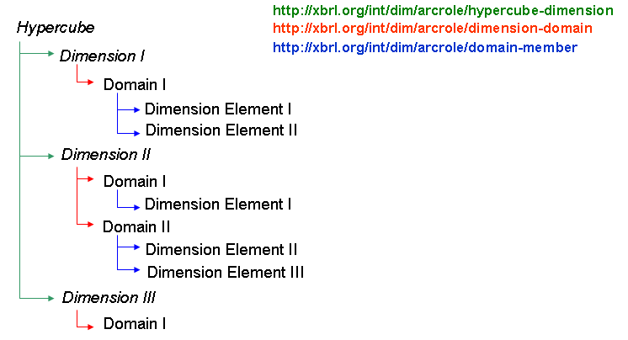
The italic elements (Hypercube and Dimension I-III) are elements defined in the template taxonomy. The other elements (Domains and Dimension Elements) are imported from the dimensional taxonomies.
According to Fig. 1, there are three different relationships:
- A relationship between the hypercube and the dimensions. The arcrole of this arc is http://xbrl.org/int/dim/arcrole/hypercube-dimension. A hypercube can consist of an arbitrary number of dimensions.
- A relationship between a dimension and its domain(s). The arcrole is http://xbrl.org/int/dim/arcrole/dimension-domain. The domain defines the elements contained within this dimension. In most cases, the domain itself is a dimensional element. A dimension can consist of an arbitrary number of domains.
- A relationship between a domain and its dimension elements. The arcrole is http://xbrl.org/int/dim/arcrole/domain-member. A domain can consist of an arbitrary number of elements. This relationship is not essential since the elements that this dimension consists of, can also be linked directly to the dimension using the http://xbrl.org/int/dim/arcrole/dimension-domain arcrole.
Each hypercube can be defined in an extended link role within the definition linkbase. The hypercubes are linked within the definition linkbase to the corresponding primary items using one of the two arcroles:

http://xbrl.org/int/dim/arcrole/all | The combination of dimensional elements defined in the hypercube may be reported for the corresponding primary item. (Valid)
http://xbrl.org/int/dim/arcrole/notAll | The combination of dimensional elements defined in the hypercube must not be reported for the corresponding primary item. (Invalid)

Overview of the COREP Taxonomy

Content
The COREP taxonomy is the COREP data model expressed in XBRL format. It is based on the final COREP templates published in January 2006. The COREP taxonomy produces the required banking supervisory information in a computer readable format. Each supervisor decides on the scope of reporting, thus the COREP Discoverable Taxonomy Set (DTS) is constructed as modular as possible. This means that the taxonomy can be easily extended or restricted.
The COREP DTS is based on XBRL Specification Version 2.1 and the Dimensions 1.0 Specification, released as a Recommendation by XBRL International on September 18, 2006 and published at http://www.xbrl.org. The DTS consists of taxonomies (.XSD files) and their corresponding linkbases (.XML files).
At present, the COREP Taxonomy uses the:
Label linkbase for labelling the elements in English language, the
Presentation linkbase to build the hierarchical structure of the elements, the
Calculation linkbase to express calculations, the
Definition linkbase to define the valid and invalid combinations of dimensions (as described in the Dimensions 1.0 Specification) and the
Reference linkbase to refer to articles and paragraphs of the European Directives that the COREP Data Model is based on (EU Directives 93/6 and 2000/12).

Structure

COREP Data Model
The COREP data model is multidimensional and consists of a set of forms (or “templates”). Each template is represented as a table within an Excel spreadsheet. Its structure can be explained as shown in the following example, the CR SA Template:
Figure 2: A COREP template (CR SA)
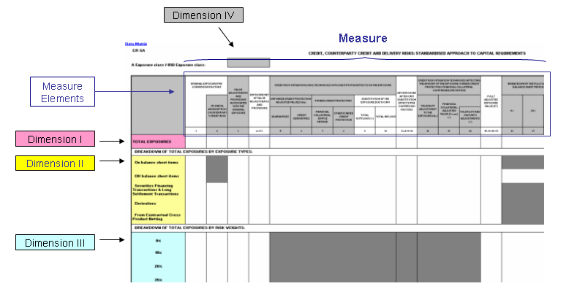
The other templates follow more or less the same structure.
The items reported horizontally are called measure elements (shown in blue in Fig. 1). A measure element is a fact about which a certain value can be reported. A measure (which is the amount of all measure elements) is shown horizontally. Each template has a unique measure.
The vertical items are called dimension elements. A dimension consists of elements which characterise a reported fact. So each reported value always refers to a certain fact (the measure element) and a certain context (the dimension elements which it is reported for). A dimension can be reused across different templates with a different subset of elements.
Since a COREP template can have multiple dimensions, it is said to be multi-dimensional. The elements of the first dimension are shown vertically in the first column. In some cases, the first column of the template already consists of multiple dimensions (in Fig. 1, the first column consists of three different dimensions). A very common use case within the COREP Data Model is a dimension element being broken down by another dimension.
However, a dimension can also appear above the template (as for example Dimension IV in Fig. 1). The dimension is presented by a coloured box, its elements do not appear within the template itself but are listed in the corresponding reference list. A reference list is added to each template in the COREP business framework.
So a template is always the combination of one measure and multiple dimensions. Currently the number of dimensions vary between 0 and 6. Figure 2 clarifies the relationship:

Figure 3: Template Segmentation into Measures and Dimensions
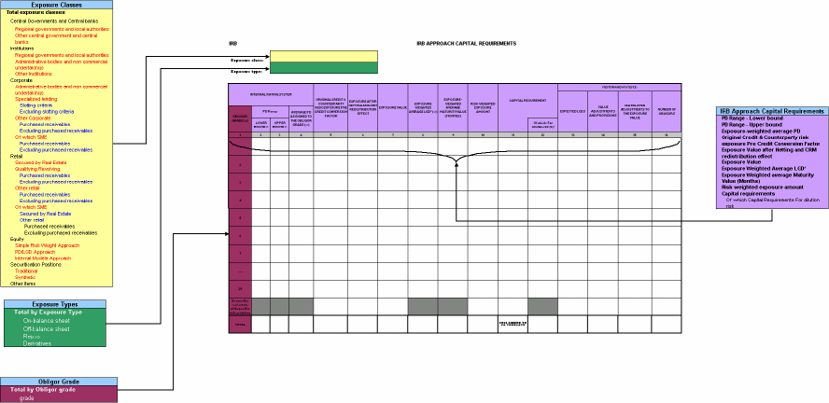
Each cell in the sample template is a combination of one item of each dimension and a measure.
measures
dimensions

Primary and Dimensional Taxonomies
Since the COREP taxonomy follows the Dimensions Recommendation, it consists of primary and dimensional taxonomies. There is one primary taxonomy for each measure of a template and one dimensional taxonomy for each dimension. The following characteristics are true for all primary and dimensional taxonomies:
- Each primary taxonomy name starts with prefix “p-“, and each dimensional taxonomy starts with “d-“.
- Each primary and dimensional taxonomy defines an abstract element which can be seen as a placeholder for all the elements within this taxonomy. This placeholder is the root element within the presentation linkbase and the definition linkbase. The label of this element ends with “(domain)”.
- The taxonomies also contain abstract elements. For example, consider the following part of a measure:
Figure 4: Measure in detail
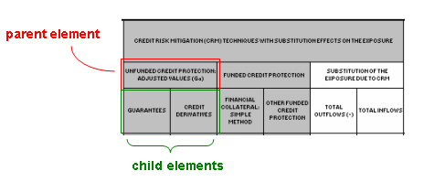
For the parent element, a value cannot be reported since the parent element is composed of two child elements. This parent element has to be declared as abstract within the taxonomy.
- The data types of the elements are mostly monetary item types, e.g. “xbrli:monetaryItemTypes”. The data types of abstract elements are “xbrli:stringItemType”.
- The substitution group in primary taxonomies is always “xbrli:item”. Some dimensional taxonomies consist of two different dimensions in business terms of view. The difference is emphasized by using a substitution group for one of these dimensions.
- The period type is always “instant”.
- The presentation and the definition linkbases both implement the hierarchical order of elements according to the templates. They also provide a default ordering that SHOULD be used when displaying tabular data. Within the presentation linkbase the elements are linked using the arcrole http://www.xbrl.org/2003/arcrole/parent-child. Within the definition linkbase the arcrole http://xbrl.org/int/dim/arcrole/domain-member is used.
- The calculation linkbase is used to define basic calculations such as summations and subtractions between measure elements.
- The label linkbase contains English labels.
- Each primary and dimensional taxonomy has a reference linkbase with references to the appropriate parts of the European Directives.

Common Primary Taxonomies introduced in version 1.2
In COREP taxonomy 1.2 (published on 2006-09-08), so-called common primary taxonomies have been introduced.
A detailed analysis of the COREP templates showed multiple business elements (as for example “Capital Requirements”) were reused in , or common to different templates.
Prior to version 1.2, each of the referenced primary taxonomies defined and contained its own instance of this concept. Defining the same concept more than once leads to redundancy and larger physical files, as well as to an increased difficulty to identify business equality at the application level.
To satisfy this business equality on the technical level, what are called common primary taxonomies have been created which only contain concepts that are used in, or common to, more than one template.
In actual fact, there are three common primary taxonomies:
- p-cm-ca: This taxonomy contains primary concepts from the CA template which are reused in other templates.
- p-cm-cr: This taxonomy contains primary concepts which are reused across the credit risk templates.
- p-cm-mr: This taxonomy contains primary concepts which are reused across the market risk templates.
To emphasise the non-commonality of the other primary taxonomies , such taxonomies will be called specific primary taxonomies.
All specific primary taxonomies which use one of the common concepts have to import the appropriate common primary taxonomy in order to access the common concept.
For example the specific primary taxonomy for the CR SA template (p-cs) uses both common elements from the CA template (defined in the common primary taxonomy p-cm-ca) as well as common elements from the credit risk templates (defined in the common primary taxonomy p-cm-cr). Therefore, the p-cs taxonomy has to import both the p-cm-ca and p-cm-cr common primary taxonomies.
The specific primary taxonomy for the OPR template (p-op) uses only common elements from the CA template and thus only has to import the p-cm-ca common primary taxonomy.

Figure 5: Specific primary taxonomies importing common primary taxonomies
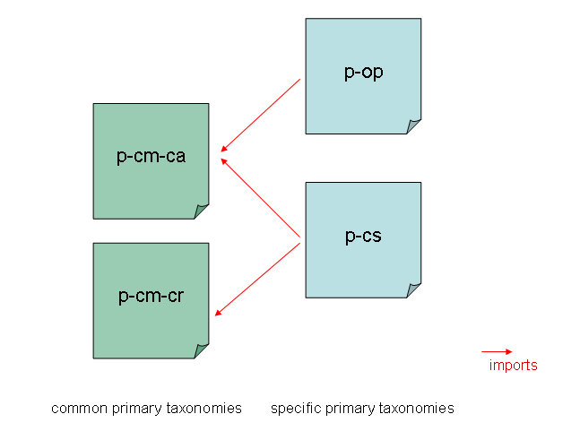
Within the specific primary taxonomy, the common concepts from the imported common primary taxonomies can be used like any other concept (e.g., they can be used to build the linkbases).

Template Taxonomy

Combining Measures and Dimensions
Each template taxonomy consists of one template taxonomy that imports one template specific primary taxonomy and none or several common primary taxonomies as well as none or several dimension taxonomies, according to the corresponding COREP template.
Figure 6: Composition of a template taxonomy

For each COREP template, one template taxonomy exists. Therefore, the COREP taxonomy consists of template taxonomies, primary taxonomies and dimensional taxonomies.
This modular structure guarantees a flexible maintenance of an extensible model that can be reused in other places. Furthermore, the modular structure eases the national adaptation of the COREP taxonomy. It is needed to know the elements with the same meaning used in different templates, i. e. for a generic database mapping. The maintenance of these elements can be reduced and the relations between templates can be identified easily. Elements with the same meaning were identified by business experts and extracted in separate primary taxonomies for each template group.
Each template taxonomy name starts with the prefix “t-“. Compared to primary and dimensional taxonomies, a template taxonomy has neither its own presentation linkbase nor a reference linkbase. The main purpose of a template taxonomy is to define the relations between primary and dimensional items, which means to describe which combinations of dimensions are valid for a primary item and which are invalid. This is done in the definition linkbase according to the rules described in the Dimensions 1.0 Specification.

Relationship between Measures and Dimensions
The definition linkbase of a template taxonomy contains information about the valid and invalid combination of dimensions. These combinations are shown in the COREP data model: Each white cell within a template represents a valid combination (since a value for this fact and the corresponding dimension elements can be reported), whereas each grey cell represents an invalid combination (since a value for this fact and the corresponding dimension elements cannot be reported).

Fig. 5 clarifies this:
Figure 5: Valid and invalid combination of dimensions
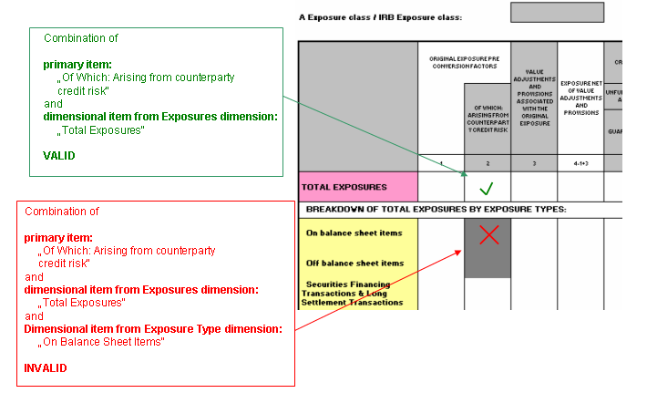
Mapping this kind of multidimensionality to taxonomies is explained within the Dimensions 1.0 Specification. Understanding the Specification is essential to understanding the COREP taxonomy.

      - Incorporation of multi-dimensionality in COREP taxonomy

The definition linkbases of the template taxonomies are the most complex part of the COREP taxonomy.

Understanding these linkbases requires the understanding of the following points:

- Within COREP templates, there are cells which refer to different dimensions. For example in Fig. 5, the cell with the green tick arrow refers only to the Exposures dimension, whereas the cell with the red cross refers to one element of the Exposures dimension in combination with one element of the Exposure Type dimension.
- Each different combination of dimensions requires its own hypercube.
- Different domains of the same dimension must be expressed in different hypercubes.
- Within one extended link role of the definition linkbase, the hypercubes which are linked to the same primary item are combined using a logical AND. There is no possibility to combine them using a logical OR within the same extended link role.
- This means that within one extended link role hypercubes can only be linked to the same primary item which refer to exactly the same dimensions. Otherwise the AND-combination is not possible. For example, if there is a hypercube hc1 which refers to the dimensions dA and dB, and a second hypercube hc2 only refers to dimension dA, both hc1 and hc2 must not be linked to the same primary item within the same extended link role.
- The COREP templates are divided into so-called “sections”. The white and grey cells of one section can be expressed within extended link roles. Therefore:
  - Within one section, no hypercubes may appear which refer to different dimensions.
  - Within one section, no hypercubes with the same dimensions may be linked to the same primary item if they are mutually exclusive. For example, consider the situation:
Hypercube hc1 refers to dimension dA with the domain dA1 and to dimension dB with the domain dB1 and dB2.
Hypercube hc2 refers to dimension dA with the domain dA2 and to dimension dB with the domain dB1 and dB2.
Now hc1 and hc2 must not be linked to the same primary item using the …/all arc, since a primary item cannot be reported for dA1 AND dA2 at the same time.

All these points cause definition linkbases to have lots of different extended link roles. Since the domain-member network of the primary items is only available in the standard link role (since the primary taxonomy is imported and contains this network within its own definition linkbase), it must be rebuilt in all the other link roles.

To ease the development, the maintenance and the understanding of the definition linkbases, the different hypercubes and sections (and hence the extended link roles) are coloured within the COREP Data Matrix. This Data Matrix summarises the different primary and dimensional taxonomies, it shows which primary and dimensional taxonomies a template taxonomy consists of, and it contains all the COREP templates.

The division of a template into sections and hypercubes shall be explained using one specific example, i.e., a part of the CR SEC IRB template:

Figure 8: Dividing a template into sections
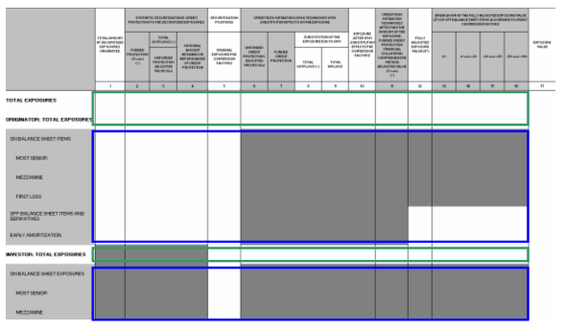

As defined by the data model, this template consists of two different dimensions: The Exposures dimension and the Exposure Type dimension (there is a third dimension within this template, which is not needed in the example).

The elements of both dimensions are shown in the first column of the template. The elements of the Exposures dimension are shown in white cells (there are three of them), and the elements of the Exposure Type dimension are shown in grey cells (there are nine of them).

The first thing to determine is which combination of dimensions each cell in the template can refer to:

A cell can refer to elements of only the Exposure dimension. This is true for all the cells within the green boxes in Fig. 7. Therefore, at least one hypercube is needed to refer to the Exposure dimension and only to the Exposure Dimension.

A cell can also refer to a combination of elements of the Exposure Dimension and the Exposure Type dimension. This is true for all the cells within the blue boxes. In this case, the Exposure Type dimension is a breakdown of the Exposures dimension elements. So at least one hypercube is needed to refer to both the Exposure and the Exposure Type dimension.

So, at the moment, the template consists of two different sections: The green section with only the Exposures dimension, and the blue section with the Exposures dimension and the Exposure Type dimension.

Now the hypercubes have to be modelled.

Regarding the green section, we see that we need two different hypercubes (remember all hypercubes within the green section refer to only the Exposures dimension).

Figure 9: Hypercubes within one section
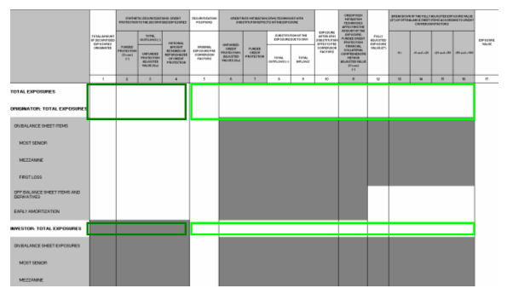

There are two possibilities to express the white and grey cells of a template:
- Allow all dimensional elements and exclude the grey cells (1).
- Only allow the white cells (2).

The hypercubes have to be modelled depending on this decision.

If (1) is chosen, there are two different hypercubes: The first one refers to the Exposures Dimension with a domain including all three elements. This hypercube can be linked to the abstract placeholder for all primary items (such a placeholder exists in each primary taxonomy, see chapter 4.2.2) using the …/all arc. The placeholder is the root element of the definition linkbase; therefore, its hypercube relations are inherited to all other primary items. The second hypercube only models the grey cells: The Exposures dimension has a domain consisting of only the third element. This hypercube can be assigned to the according primary items using the …/notAll arc. These primary items now have two different hypercubes linked to them: One is inherited from the abstract placeholder, the other is directly linked to them. This is valid since both hypercubes refer to the same dimensions and are not mutually exclusive.

If (2) is chosen, there are two different hypercubes again: The first one is exactly the same as in (1) and allows all elements. But now it is not linked to all the primary items, but only to those it actually refers to, so that means only to those for which all the dimensional elements are explicitly allowed. The arc role again is …/all. The second hypercube includes only the first two elements, and this hypercube is linked to the remaining primary items using again the /…all arc.
In this case, there is no primary item having two hypercubes linked to it.

Which of these two possible choices to select is mainly a question of design. Both are valid, and currently there is no consensus within the COREP taxonomy.

Regarding the second section (blue section in Fig. 7), this leads to the following hypercubes (remember all hypercubes of the blue section have to refer to both the Exposures dimension and the Exposure Type dimension):

Figure 10: Hypercubes within one section
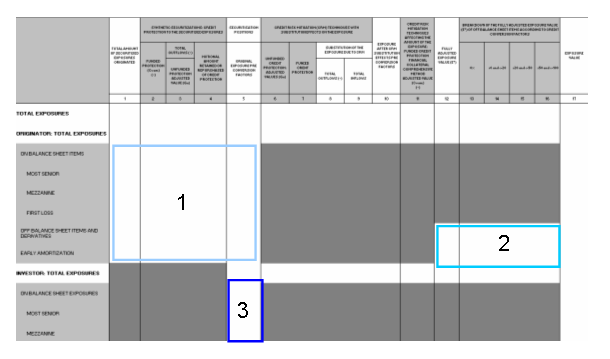

Again, two alternatives are possible:
- Allow all the combination of both dimensions (cartesian product) and exclude the grey cells (1).
- Allow only the white cells (2).

Considering that a cartesian product offers many possibilities and might be too complex, we will take the second approach.

So, three different hypercubes have to be modelled:

Hypercube 1 contains the Exposure dimension; its domain only consists of the element “Originator: Total Exposures”. Furthermore, it contains the Exposure Type dimension, the corresponding domain consists of the appropriate six elements.

Hypercube 2 contains the Exposure dimension with the same domain as hypercube 1 (only one element), the Exposure Type dimension contains a domain consisting of two elements (since only two elements of the Exposure Type dimension are allowed (valid) and the remaining four elements are grey (invalid).

Hypercube 3 contains the Exposure dimension. The corresponding domain again consists of only one element, but this time it is “Investor: Total Exposures”. The Exposure Type dimension has a domain with the corresponding three elements.

These hypercubes must be linked to the primary items using the …/all arc. Of course, this must happen in another extended link role different from the hypercubes of the green section, since the “blue” hypercubes refer to another combination of dimensions.

The difficult point here is, whereas all the green hypercubes could be linked to the primary items within one extended link role (no matter if approach (1) or (2) is chosen), this is not possible with the blue hypercubes.

Since all the hypercubes are linked to the primary items using the …/all arc, and there is one primary item which is linked to two different hypercubes (hypercube 1 and 3 are both linked to the same primary item), both hypercubes must not be mutually exclusive.
But, in this case, they are. If both hypercubes were linked to the same primary item, they would be combined using the logical AND. But the primary item can never be reported for the Exposures dimension element “Originator: Total Exposures” AND “Investor: Total Exposures” at the same time!

Therefore only hypercube 1 and 2 can be reported within the same section, hypercube 3 must be reported in a different section (= different extended link role in the definition linkbase).

That is the principle of how sections and hypercubes are defined in the templates. As mentioned above, all the sections and cubes are coloured in the COREP Data Matrix, so it is easier to understand them and to compare them with the definition linkbase.

Technical aspects of the definition linkbase

There are a few technical aspects which are worth mentioning.

Since the domain-member network of the dimensional elements already exists in the standard link role (since this is imported from the dimensional taxonomy), it does not have to be rebuilt in other link roles.

Instead, in the arc whose destination is a certain dimension element, the attribute targetRole of the namespace http://xbrl.org/2005/xbrldt can be used. The value of this attribute is a link role. The targetRole attribute indicates the same domain-member network for the destination element as it has in the link role that the attribute points to. So this is an easy way of rebuilding already existing networks.

The targetRole attribute is also used in the arc which links a primary item element to a hypercube. This attribute points to the extended link role where the hypercube is defined. Therefore, the hypercube network (consisting of a hypercube, dimensions and domain, see Fig. 6) is only defined in one link role and reused in other link roles using the targetRole attribute.

Although it would also be possible to reuse domain-member networks of primary items across different link roles with the targetRole attribute, this is not done in the COREP taxonomy. The reason is the degree of complexity regarding the relationships to different hypercubes across different extended link roles. Since this could lead to confusion, the domain-member network of primary items is explicitly rebuilt in every link role it is needed.

There are two other important attributes used in the arc between a primary item and a hypercube.

One is the contextElement attribute of the same namespace http://xbrl.org/2005/xbrldt. It indicates whether the dimensions a fact refers to are reported in the scenario or in the segment element of the context of an XBRL instance document. Within the COREP taxonomy, the value of the contextElement attribute is always “scenario”.

The other important attribute also belongs to the http://xbrl.org/2005/xbrldt namespace and is called “closed”. It indicates whether the assigned hypercube is closed, which means it is not allowed to add further dimensions in an instance document. Since this ought to be not allowed by the COREP taxonomy and since the default of the closed attribute is “false”, this attribute is explicitly set to “true”.

Some specific hypercube structures – the d-hh taxonomy

There are two specific hypercube structures which require a more detailed explanation.

If a template taxonomy imports a (specific) primary taxonomy which itself imports a common primary taxonomy (see chapter 4.2.3), there might be several common primary concepts which are not needed at all for this template. For example, the specific primary taxonomy for the OPR taxonomy (p-op) imports the common primary CA taxonomy (p-cm-ca), but needs only one concept.

Since the other common primary concepts have no assigned hypercubes in the definition linkbase of the template taxonomy, the dimensional validation does not apply and they would be valid in an instance document, if reported. This of course has to be prevented because these concepts must not be reported at all.

The mechanism to avoid these concepts from being reported is to assign a hypercube which is always invalid – a hypercube with an empty dimension. This hypercube is defined in the d-hh-2006-07-01.xsd taxonomy. Its name is “hyp-cm_ProhibitingHypercube” and its label “Helper Prohibiting (Hypercube)”. The assigned dimension is called “Helper Null (Dimension)”. The d-hh taxonomy also contains a placeholder concept for all the primary concepts which are “prohibited” in this way (“hyp-cm_ProhibitedItemsPlaceholder”).

In the affected template taxonomy, this placeholder concept is used on top of the domain-member network of all the common primary concepts (including those which are allowed in this template), and the “Helper Prohibiting (Hypercube)” is assigned with an “…all” arc. This is done in the extended link role which ends with “SectionProhibitedItems”.

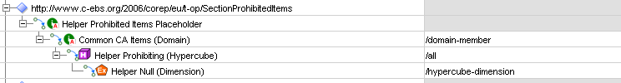

This structure disallows all common primary concepts for this template, since the hypercube with the empty dimension is assigned to all of them. However, there is at least one other extended link role which allows the correct common primary concept(s) for the according dimensional combination, and according to the XBRL Dimensions Specifications, this is sufficient to make the correct common primary concept valid in an instance document.

The second specific hypercube structure is a hypercube without any dimension (please do not mistake this for the hypercube with an empty dimension). The hypercube without any dimension is also defined in the d-hh taxonomy and is called “hyp-cm_EmptyHypercube”. This hypercube has to be assigned to all primary concepts which ought to be reported without dimensions. The d-hh taxonomy also contains a placeholder for those concepts called “hyp-cm_AdimensionalItemsPlaceholder”.

In a template with dimensionless primary concepts, the abstract placeholder “hyp-cm_AdimensionalItemsPlaceholder” (or any other placeholder) is on top of the domain-member network of those dimensionless concepts. This is done in the extended link role which ends with “SectionAdimensionalItems”. The hypercube without dimensions is assigned to the placeholder concept using an “…/all” arc.

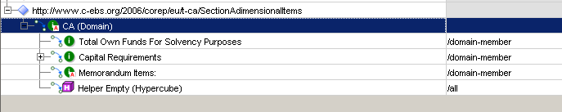

Collecting typed dimensions – the d-ty taxonomy

Whereas dimension concepts of explicit dimensions are defined in the appropriate dimension taxonomies, dimension concepts of typed dimensions are defined together in a base taxonomy called d-ty-2006-07-01.xsd.

A typed dimension has no pre-defined domain members like an explicit dimension, so the domain members can be freely chosen by the user. These typed domain members are validated against a common XML Schema element. The typed dimension concept is linked to the XML Schema element against which its members are validated, with the typedDomainRef attribute of the http://xbrl.org/2005/xbrldt namespace.

Here is an example:

The concept is a typed dimension concept and called “DayDimension”. The XML Schema element which all domain members of this dimension have to match to is the d-ty_Day element in the d-ty-2006-07-01 schema file (= taxonomy).

Therefore, every template taxonomy using a typed dimension has to import the d-ty taxonomy to access its specific typed dimension concept(s).

Organisation of Linkbases
There are two important extended link roles in primary, dimensional and template taxonomies which occur in every linkbase:

- The standard extended link role http://www.xbrl.org/2003/role/link
- A template specific extended link role http://www.c-ebs.org/2006/corep/eu/template-prefix, where the template-prefix is the two-letter abbreviation (or five in case of common primary taxonomies) of the according template. So, the specific extended link role of the CA template is http://www.c-ebs.org/2006/corep/eu/ca. Please remember that the specific extended link role does not differ between a primary or a template taxonomy for the same template.

The following list explains how these link roles are used within the individual linkbases of the taxonomies:

- Label Linkbase

Common primary taxonomy
The label linkbase of a common primary taxonomy contains the labels for the common primary concepts under the standard link role. There is no specific link role.

Specific primary taxonomy
The label linkbase of a specific primary taxonomy contains the labels for the specific concepts under the standard link role. If an imported common concept has a different label within this specific template than the one defined in the common primary taxonomy, this new label is defined under the specific link role.

Dimensional taxonomy
The label linkbase of a dimensional taxonomy contains the label of the dimension concepts under the default link role.

Template taxonomy
The label linkbase of a template taxonomy contains the label of its concepts (hypercubes) under the default link role.

The label linkbase of primary and dimensional taxonomies also contain the information whether a specific concept belongs to the “core” or the “detailed” layer of the COREP business model. Business elements in the core layer are supposed to be used in almost every country, whereas elements of the detailed layer are going to be used by only a few number of countries.

If an element belongs to the core layer, the related taxonomy concept refers to a label called “Core layer”. This label is under the specific link role with the label role “/documentation”. If an element belongs to the detailed layer, this label is called “Detailed layer”, respectively.

- Definition Linkbase

Common primary taxonomy
The definition linkbase of a common primary taxonomy contains all common primary concepts under the specific link role (e.g. http://www.c-ebs.org/2006/corep/eu/cm-ca).

Specific primary taxonomy
The definition linkbase of a specific primary taxonomy contains the domain-member network for its corresponding template under the specific link role. This domain member network can include both specific and imported common primary concepts.

Dimensional taxonomy
The definition linkbase of a dimensional taxonomy contains the domain-member network for its corresponding dimension under the specific link role.

Template taxonomy
As described in chapter 4.2.4, the definition linkbase of a template taxonomy contains the hypercube structures and assigns them to the corresponding primary concepts in various extended link roles (they follow a certain naming convention, which is explained in chapter 4.3).

- Presentation Linkbase

Specific primary taxonomy
The presentation linkbase of a specific primary taxonomy contains the hierarchical structure of the primary items for its corresponding template under the specific link role. This hierarchy can include both specific and imported common primary concepts and is equal to its definition linkbase.

Dimensional taxonomy
The presentation linkbase of a dimensional taxonomy contains the hierarchical structure of the dimensional concepts for its corresponding dimension under the specific link role. The structure is equal to its definition linkbase.

- Calculation Linkbase

Specific primary taxonomy
The calculation linkbase of a specific primary taxonomy contains calculations between primary items for its corresponding template under the specific link role (or extensions of the specific link role if more than one calculation network is needed). These calculation networks can include both specific and imported common primary concepts.

Dimensional taxonomy
There is no need for a calculation linkbase in dimensional taxonomies since calculations between domain members is currently not supported by XBRL. This is going to be introduced with the formula linkbase.

- Reference Linkbase

Specific primary taxonomy
The reference linkbase of a specific primary taxonomy contains references to the according EU directives under the specific link role.

Dimensional taxonomy
The reference linkbase of a dimensional taxonomy contains references to the according EU directives under the specific link role.

Template taxonomy
The reference linkbase of a template taxonomy contains references for the common primary concepts used in this template because these references are template-based and might – due to the business equalitiy of these elements – differ between the templates. As usual, the references are under the specific link role.

Creating instance documents
An instance document contains contexts whose <scenario> elements point to specific dimension members in one or more dimension taxonomies. So, both the dimensions and the specific dimension elements that a fact refers to can always be determined by the corresponding context of that fact.
It is important to remember that this has nothing to do with hypercubes and the principle explained in the previous chapter: Hypercubes are used to express combination of dimensions and to link them to specific primary items. Hypercubes are necessary to determine whether a specific combination of dimensions is valid or invalid for a specific primary item. The instance document declares which combination of dimensions a fact refers to. Whether this is a valid combination or not has to be determined by XBRL, and the hypercubes defined in the taxonomies are used for that.
For the creation of an instance document that contains dimensions linked to the primary items, it is necessary to use the xbrldi-2005-11-07.xsd schema file in the instance document.
Figure 11: Structure of a dimensional instance document
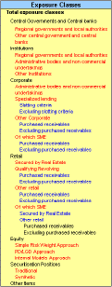
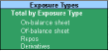
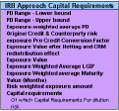
<xbrl …>
<context id="context-1">
<entity>…</entity>
<period>…</period>
<scenario…>
<!– possible combination
of dimensions →
</scenario>
</context>

<!– measures →
<t-sa-cr:ExposureValue
contextRef="context-1"…>4000
</t-sa-cr:ExposureValue>…
</xbrl>
dimensions
measures

This schema defines an “explicitMember” element for explicit dimensions and a “typedMember” element for implicit (= typed) dimensions which is an extension of QName with xlink attributes to define a simple relationship to the dimension Placeholder element.
The syntax to express a dimension is as follows:
<http://www.xbrl.org/2003/instance:scenario>
<http://xbrl.org/2006/xbrldi:explicitMember dimension=”NamespaceOfSchema:NameOfDimensionPlaceholder”>
NamespaceOfSchema:NameOfDomainMember
</http://xbrl.org/2006/xbrldi:explicitMember>
</http://www.xbrl.org/2003/instance:scenario>

An example (with namespace prefixes instead of URIs):

<xbrli:scenario>
<xbrldi:explicitMember dimension=”dba:BankActivityDimension”>
d-ba:TotalBankingActivities
</xbrldi:explicitMember>
</xbrli:scenario>

So, the “dimension” attribute always points to the name of the abstract element which represents the affected dimension, and the value of the “explicitMember” element is the name of the specific dimension element.

If the corresponding dimension is open (that means, the dimensional elements are not explicitly defined, only their structure is given), the name of the element is “typedMember”.

The “scenario” element can contain an unlimited number of “explicitMember” or “typedMember” elements, depending on the number of different dimension elements a fact refers to.

Naming Conventions
The naming convention for element names is upper camel case concatenation without dots. All element names are based on the presentation label for the element. The first character SHOULD be capitalised and alphabetic. The connective words SHOULD be omitted from the element name to shorten them. All special characters are omitted from the element name. The element names in a taxonomy are unique.
The COREP Taxonomy has its convention corresponding to the naming of the taxonomies. The first two characters of the taxonomy name identify the specificity of the taxonomy:
- “d-“ for dimensional taxonomies,
- “p-“ for (specific) primary taxonomies (see chapter 4.2.3),
- “p-cm-“ for (common) primary taxonomies (see chapter 4.2.3),
- “t-“ for the template taxonomies.

The next two letters is the prefix for this taxonomy. The Data Matrix contains the information on which prefix belongs to which taxonomy. After this, a date follows, so the complete name for a taxonomy is for example:
p-ca-2006-07-01.xsd
The target namespace of a taxonomy always starts with http://www.c-ebs.org/eu/fr/esrs/corep/ followed by the same date as in the name of the taxonomy and the name of the taxonomy itself. Therefore the target namespace for the d-ba-2006-07-01.xsd taxonomy is:
http://www.c-ebs.org/eu/fr/esrs/corep/2006-07-01/d-ba-2006-07-01
None of the schema files uses a default namespace. All namespaces are declared explicitly and have a defined prefix.
Many of the linkbases use a so-called template specific extended link role (see chapter 4.2.5 for an explanation of its use). This extended link role starts with http://www.c-ebs.org/2006/corep/eu followed by the template prefix of the corresponding template. Therefore, the specific extended link role of the OPR taxonomy (prefix OP) is:
http://www.c-ebs.org/2006/corep/eu/op
The name of domain concepts which are used on top of domain-member networks of primary and dimensional concepts ends with “Domain”. The label ends with “(Domain)”.
The name of dimensional concepts which represent a whole dimension ends with “Dimension”. The label ends with “(Dimension)”.
The name of hypercube concepts which represent a one- or multidimensional structure ends with “Hypercube”. The label ends with (“Hypercube”).
Template taxonomies define the structure of hypercubes and assign them to the according primary concepts in various extended link roles in their definition linkbase. These extended link roles always start with http://www.c-ebs.org/2006/corep/eu/ followed by the prefix of their corresponding template and a short name explaining the purpose of this link role. So the name of an extended link role in the t-op template is for example
http://www.c-ebs.org/2006/corep/eu/t-op/SectionBankingActivities
Extended link roles for disallowed primary concepts (see chapter 4.2.4.6) always end with “SectionProhibitedItems”. Extended link roles for dimensionless primary concepts (see chapter 4.2.4.6) always end with “SectionAdimensionalItems”.
The ID of roleTypes used in the definition linkbase of template taxonomies always starts with “rt_” followed by the prefix of the corresponding template and the last part of the corresponding extended link role. So, the ID of the roleType mentioned above is
rt_t-op_SectionBankingActivities

Taxonomy Testing
Testing of the COREP taxonomy will be carried out in parallel with taxonomy development. Extensive testing using anonymous data to test the entire taxonomy will also be performed. Additional sample data will be used to achieve a 100% coverage test of the taxonomy. See www.corep.info for details.

Overview of the FINREP Taxonomy

Content
The FINREP taxonomy is the FINREP data model expressed in XBRL format. It is based on the final version of the templates published by the CEBS. As with the COREP taxonomy, the FINREP taxonomy describes the required Banking Financial Information in a computer readable format. It is very important to note at this point that FINREP is based on the IFRS-GP 2006 taxonomy which has been published by the IASB at http://xbrl.iasb.org/int/fr/ifrs/gp/2006-08-15/summary_page.html. In order to reduce the burden on supervised entities, and in accordance with the spirit of XBRL, the CEBS has opted to create its FINREP taxonomy as an extension of the IFRS-GP 2006.
FINREP uses a number of elements from the IFRS-GP 2006 taxonomy. However it does not make use of its presentation and calculation linkbases. Any elements that are specific to FINREP have been created in the primary FINREP taxonomy p-FINREP, and new linkbases for FINREP have been added: presentation linkbase, definition linkbase, calculation linkbase, label linkbase and reference linkbase. There is another important difference between FINREP and the IFRS-GP 2006 taxonomy: In maintaining a common methodology between FINREP and COREP, the CEBS has decided not to use XBRL tuples and has implemented the FINREP Data Model by using the dimension specification in much the same way as COREP.
The FINREP DTS is based on XBRL Specification Version 2.1 and the Recommendation for Dimensions 1.0 Specification, as published at http://www.xbrl.org. The DTS consists of taxonomies (.XSD files) and their corresponding linkbases (.XML files).
At present, the FINREP Taxonomy uses the:
IFRS-GP 2006 schema file with its label and reference linkbases.
Label linkbase for labelling the elements in English language, the
Presentation linkbase to build the hierarchical structure of the elements, the
Calculation linkbase to express calculations, the
Definition linkbase to define the valid and invalid combinations of dimensions (as described in the Dimensions Specification) and the
Reference linkbase to refer to appropriate documentation.

Structure

FINREP Data Model
To understand the FINREP data model one should start from the COREP Data Model. There are a number of factors, however, that cause the FINREP Data Model to slightly diverge from that of COREP. Some of these are the following:
- FINREP is targeted toward reporting financial information, while COREP’s scope is supervisory information.
- FINREP is an extension of an existing taxonomy and, as such, it makes sense to use what is already in place as much as possible.
- In COREP, many cells have been created as combinations of a measure element and a number of dimensions. However, in FINREP, many cells have already been defined as measure elements in the XBRL-GP taxonomy.
- In FINREP, there is an emphasis on applying the validation process via the calculation linkbase. This can only be achieved if cells are created as individual measures rather than combinations of measures and dimensions.
In trying to visualise the use of dimensions in the FINREP templates, the project team has created a file called the “FINREP EXCEL SAMPLE FIGURES.xls” file which accompanies the FINREP taxonomy. This is the definitive starting point for anybody trying to understand the structure of the taxonomy. The following is obvious simply by comparing the following figures.

Figure 12: FINREP Table 4 in the Excel file accompanying taxonomy. Colours help to understand the structure of the taxonomy. (Green denotes dimensions)
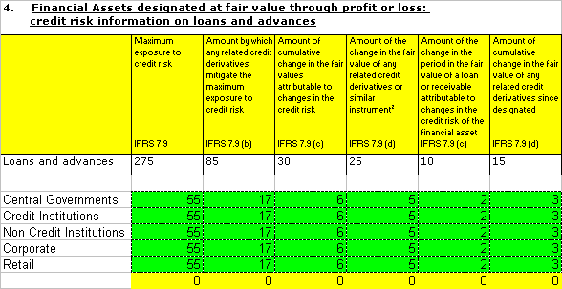
Figure 13: Table 4 is provided in the Excel file published by the CEBS. The use of dimensions is not immediately apparent.
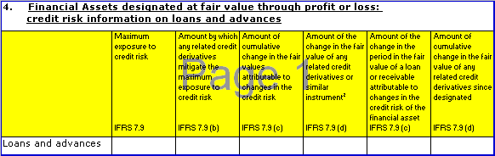
However, there is more information in the Excel file provided with the taxonomies. It should always be used when extending FINREP.
Figure 14: Table 5, as provided in the Excel file published by the Project Team.

One can see from the above that the FINREP taxonomy works by combining measures and dimensions. However, the measures are usually the combinations of rows and columns, and the dimensions have been added visually by using the green colour either on cells or in other cases on table titles.

Figure 15: Table 12 is provided in the Excel file published by the Project Team.

In some cases, to make the connection between the Excel tables and the taxonomy in FINREP requires one to carefully study the taxonomy it self.
Similar to COREP, any FINREP Table is the combination of measures and multiple dimensions. The number of dimensions can vary between 0 and 3. For an overview of the use of dimensions in the FINREP tables, the project team has created the FINREP data matrix which is embedded below and will be published on the FINREP.info web site.

Primary and Dimensional Taxonomies
FINREP consists of only one Primary Taxonomy, intuitively named p-FINREP. This taxonomy imports the IFRS-GP-2006 taxonomy and, of course, adds all the required additional measure elements. As we have already mentioned, it only imports references and English labels from IFRS-GP. All presentation, definition, and calculation relationships have been recreated. There are, however, a number of elements imported from the IFRS-GP that are not included in either the presentation, definition or calculation linkbases.
In FINREP, each table contains its own set of measure elements. The grouping of the elements into tables is achieved by creating one unique extended link for each table. These extended links are recreated in the presentation, definition and calculation linkbases, with the corresponding information being introduced in each linkbase, as can be seen below. It should be noted that there are multiple cases of measure elements that reused in more than one of the extended link roles defined in p-FINREP.

Figure 16: The linkbases of the primary FINREP taxonomy.
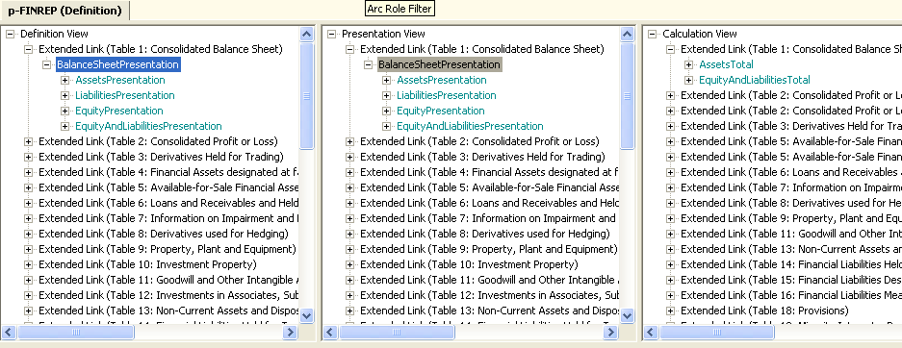
There are a number of dimensional taxonomies. Their names all start with d- followed with an abbreviation of the dimension they are used for. Contrary to COREP, each typed dimension exists in its own file. Similar, on the other hand, to COREP, the following is true for the primary and dimensional taxonomies:
- Each dimensional taxonomy starts with “d-“.
- Each dimensional taxonomy defines an abstract element which can be seen as a placeholder for all the elements within this taxonomy. This placeholder is the root element within the presentation linkbase and the definition linkbase. The label of this element ends with “(domain)”.
- In the definition and presentation linkbases of the primary taxonomy, each extended link role that represents a table has a root element with a name that always ends with the word “Presentation”.
- The data types of abstract elements are “xbrli:stringItemType”.
- The substitution group in the primary taxonomy is always “xbrli:item”.
- The presentation and the definition linkbases both use the hierarchical order of elements according to the templates. They also provide a default order that SHOULD be used when displaying tabular data. In the presentation linkbase, the elements are linked using the arcrole http://www.xbrl.org/2003/arcrole/parent-child, whereas in the definition linkbase, the following arcrole is used: http://xbrl.org/int/dim/arcrole/domain-member.
- The calculation linkbase is used to define calculations such as summations and subtractions between measure elements in the primary taxonomy. The calculation linkbase is used much more extensively than in COREP.
- The label linkbase contains English labels.
- The primary and dimensional taxonomies have a reference linkbase with corresponding references.

Template Taxonomy
FINREP consists of only one template taxonomy named t-FINREP. This imports the primary p-FINREP and all the dimension taxonomies. In its definition linkbase, all the relationships between measures and dimension are defined. It should be noted that in the case of FINREP 1.0, each typed dimension exists in its own taxonomy file, whereas in COREP 1.2 all typed dimensions have been merged into one file.

Relations between measures and dimensions in FINREP
Although the visualisation of the FINREP templates differs from that of the COREP, the underlying methodology is very similar. The concepts of measure and dimension elements are used. It is important to note, however, that there is a large number of measure elements in FINREP that do not have dimensions attached to them. Another important point is that, unlike COREP, the FINREP templates do not follow a uniform visualisation of their structure. In some cases, dimensions are represented as columns, and in other cases dimensions exist as rows, and in even other cases, such as Table 12 A and B, the use of dimensions has to be inferred by the green colour of the table titles. The key to understanding the FINREP templates is to always take into consideration the colour of the cell. In the “FINREP EXCEL SAMPLE FIGURES.xls” file that accompanies the FINREP taxonomy, the sheet named “How to read the document” always provides additional information on the meaning of each colour.
Figure 17: FINREP Table 5 in Excel file accompanying taxonomy. Colours help to understand the structure of the taxonomy.
Figure 18: FINREP Table 5 in Excel file accompanying taxonomy. Colours help to understand the structure of the taxonomy.
Apart from the colour clues in the accompanying Excel file, FINREP spreadsheet also contains Excel formulas which are essential to understand both the templates and their structure. In the case of dark blue cells, the Excel formulas show how the cell is used in the calculation link base, and in the case of light blue cells, the Excel formulas show that the measure element is used in other tables.
All yellow cells are calculations that cannot be currently validated in the FINREP taxonomy. As has been previously stated, some cells are reported using the dimension specification. Each dimension combination is reported in its own contex,t and cross context calculations are not yet implemented in XBRL. These cross context calculations will be implemented in future versions of FINREP using the upcoming XBRL Formula Linkbase.

Incorporation of XBRL multidimensionality in FINREP
As we have mentioned, much of the information in FINREP can be reported with or without dimensions. This is the due to the fact that many measure elements have been imported directly from the IFRS-GP 2006 taxonomy, instead of being defined as combinations of measures and dimensions. For this reason, FINREP tends to be simpler than COREP in its use of dimensions.

In FINREP, any measure element that can be reported using dimensions is attached to a hypercube with the “…/all” arc. Disallowed combinations are defined using exclusion hypercubes and linking them with a “…/notAll” arc to the necessary elements. No special extended link roles are created for table sections, as the domain member network for each FINREP table is defined in one extended link role.

All the hypercubes in FINREP are defined in their own extended link roles, starting with “hc” and ending with “Hypercube”. The elements of the substitution group “HypercubeItem” also have names that begin with “hc” and end with “Hypercube”, and their labels end with the word “Hypercube”. The extended link roles define the dimensions contained in each hypercube is by linking the dimension head to the hypercube item with the “hypercubeDimension” arc, and the dimension domain head to the dimension head with the “dimensionDomain” arc. The dimension domain head elements point via their “targetRole” to the default extended link where the domain member network of the dimensions is defined.

All measure domain member networks are defined in the p-FINREP primary taxonomy and are thus imported into the t-FINREP. Hypercube elements are attached to the measure elements in the definition linkbase of t-FINREP and always point to their structure in their respective extended link role via their “targetRole” attribute.

FINREP makes extensive use of the “…/dimensionDefault” arc. All dimensions contain such a default value which is usually the total of all the dimension domain members. Since the XBRL dimension specification states that dimension default members must not be used in the scenario of the context, but are inferred when not present, this gives the capability of reporting total values for measures that have dimensions, along with values of measures that do not have dimensions. All the “…/dimensionDefault” arcs are created in the http://www.c-ebs.org/eu/fr/esrs/finrep/2006-09-30/role/DimensionDefault extended link.

Figure 19: FINREP Table 5 in Excel file accompanying taxonomy. Colours help to understand the structure of the taxonomy.

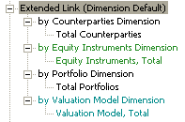

Finally, it should be noted that in the definition linkbase of the p-FINREP taxonomy there exist extended link roles for all the FINREP tables even though some of them might not include dimensions. This has been done in order to simplify the creation of extensions by national supervisors. They will not have to create the structure of the measure elements, but rather possibly reuse that which is defined by the CEBS.

Technical aspects of the definition linkbase
The same concepts of COREP apply to FINREP. Please read the relevant chapter.

The NoDimensions Extended Link Role.
In FINREP, all the measure elements are linked to an empty hypercube, i.e., a hypercube with no dimensions in the http://www.c-ebs.org/eu/fr/esrs/finrep/2006-09-30/role/NoDimensions . This forces any FINREP measure element not linked to another hypercube to only be reported in contexts without dimensions. Anything else will raise an error with the dimensional validation of the instance document.

Unused elements imported from IFRS-GP 2006
FINREP imports all the elements of the IFRS-GP 2006. However, a certain number of those elements are not used by the FINREP taxonomy. They do not appear anywhere in the presentation, calculation or definition linkbases. It is true that these elements could be used in an instance document without the XBRL parser raising any error. This case has been considered by the project team, and the decision has been made not to implement the blocking of these elements in the taxonomy. It is the belief of the project team that this should be done at the application level, e.g. after XBRL validating a custom built application that would check and raise errors for all elements reported but that are not used in the presentation, calculation or definition linkbases
However, if any national extension wishes to use XBRL validation to block these elements from being reported, it should attach these elements to an impossible hypercube in the definition linkbase, as described in the relevant COREP chapter.

Creating instance documents
The FINREP taxonomy is shipped with a sample instance document that can be used for testing the taxonomy and any extensions for it. For further reading on how an instance document should be structured, please read the following: COREP documentation on Instance creation.
It should be noted once again that FINREP makes extensive use of “dimension default” domain members in its dimensions. These dimension values must not appear in the scenario section of the context as they are inferred when the scenario section of the context does not contain a value for a required dimension of a measure. This technique allows for measure elements with a dimensional breakdown to be reported in the same context (one with no scenario) as measure elements without a dimensional breakdown, thus enabling calculations to be validated for a larger number of measure elements.

Naming Conventions
To be consistent, the project team has used the same naming conventions in both COREP and FINREP. These can be found in the relevant COREP chapter. We will only refer to the differences here:
The dimensional taxonomy names start with d- but are followed not by 2 simple characters, but by an abbreviation of the dimension name.
The target namespace of the taxonomies always starts with http://www.c-ebs.org/eu/fr/esrs/finrep followed by the prefix of the taxonomy and the publication date. In the case of the template taxonomy t-FINREP, the namespace is as follows:
http://www.c-ebs.org/eu/fr/esrs/finrep/t-FINREP/2006-09-30
The linkbase specific extended link roles in FINREP start with http://www.c-ebs.org/eu/fr/esrs/finrep/2006-09-30/role/
There are no extended link roles for disallowed primary items in FINREP, and the ids of the roleTypes have been left as they were automatically created by the taxonomy editing software.

Taxonomy Testing
The FINREP taxonomy has been extensively tested with dummy data. This data is presented in the “FINREP EXCEL SAMPLE FIGURES.xls” file and has been used to generate the “instance.xml” file that accompanies the FINREP taxonomy.

National Taxonomy Customisation COREP - FINREP
Extending the COREP and FINREP taxonomies is a similar process. In this chapter a COREP template is used for demonstration purposes; however, all the information provided below holds true for FINREP, as well. Please always take into account that FINREP modularisation is achieved by the use of extended link roles in only one primary taxonomy.
As described in Chapter 2.1, the COREP - FINREP taxonomies have been developed to be customisable – that means extensible and restrictive – by national supervisors. To facilitate the customisation of the taxonomies, the framework is as modular as possible and the structure of the taxonomies is similar to the construction of the CEBS COREP - FINREP templates. This means that the templates consist of measure and dimensions which are combined in a table. Therefore, the COREP taxonomy set consists of measure (primary dimension), dimension and template taxonomies.
In order to build extension taxonomies, the use of a taxonomy editing tool is recommended for their creation and maintenance. Links to useful XBRL tools for evaluation are available on the XBRL International website (http://www.xbrl.org).

National extension structure
National extensions will use the COREP taxonomy as a base. Extensions are done by creating new taxonomies and importing the corresponding COREP taxonomies. So, the national extension taxonomy contains all the functionality of the underlying COREP taxonomy. Changes are made in the national extensions without amending the base COREP taxonomy. The national extension taxonomy can overwrite all the rules that are defined in the imported COREP taxonomy.
Greek COREP
Taxonomy
German COREP
Taxonomy

imports

imports
COREP Taxonomy

Categorisation of national taxonomy extensions
Customisations can be made on:
- labels
- references
- the template structure
- calculations.
The following chapters deal with these customisations and how these changes can be made easily for national extension taxonomies.

Creating extension taxonomy
All customisations start with the creation of a reference to the COREP taxonomy. This is done by building a new national taxonomy and importing the corresponding COREP taxonomy.
To customise a COREP template, a national taxonomy (i.e. “t-me-ISO country code-2006-MM-dd”) must be created. After setting up all the properties and the national namespace, the corresponding taxonomy of COREP should be imported.
<?xml version="1.0" encoding="UTF-8"?>
<xsd:schema targetNamespace="http://www.bundesbank.de/corep" … >
<xsd:import namespace="http://www.xbrl.org/2003/instance" schemaLocation="http://www.xbrl.org/2003/xbrl-instance-2003-12-31.xsd"/>

<xsd:import namespace="http://www.c-ebs.org/eu/fr/esrs/corep/2005-12-31/t-me-2005-12-31" schemaLocation="t-me-2005-12-31.xsd"/>

</xsd:schema>

After the import, the national extension taxonomy possesses the complete functionality of the underlying COREP taxonomy.

Customisation of labels
The labels of the COREP taxonomy contain the captions of the columns and rows of the templates and can be used to create reports. For example, the receipt of an XBRL instance document could be transformed into other formats as Adobe Pdf or Microsoft Excel to enable easier viewing of the data. In such documents, the labels are used to hide the technical element name. To generate reports in the national language, the English labels of the COREP taxonomy should be translated accordingly. This is done by adding a label linkbase to the extension taxonomy. In this way, each national supervisor can create a COREP dictionary to present reports in one or more languages.
<GOLD id=“p-mf-de_Gold”> technical name
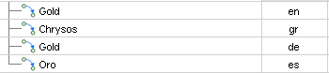

National labels

Customisation of references
The COREP templates are based on the EU directive of Basel II. Therefore, references to this EU law will be added to the elements of the COREP taxonomies in version 1.0. If a national law exists that defines what must be reported, this law should be added as a reference because it overrides the rules of the EU directive.
Additional references are added by extending the national taxonomy with another reference linkbase.
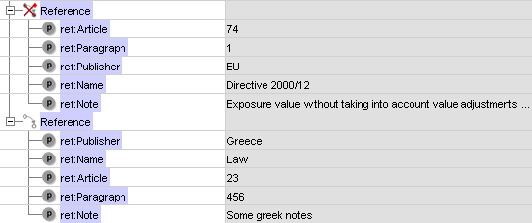
ORIGINAL CREDIT & COUNTERPARTY RISK EXPOSURE…

A reference to the COREP base taxonomy can be removed by prohibiting the use of the reference arc.
The references build a good glossary because by following the reference of an element, the explanation of what has to be reported can be found in the EU directive or in the national law. No further descriptions are needed.
The COREP taxonomy uses a specific reference structure that accommodates the structure of the EU directive. The national law might have a different structure. To customise the reference structure, the basic reference linkbase should be extended by adding additional elements. This is done similar to the description of an extension of COREP taxonomies (Chapter 6.3).

Customisation of the template structure
This sub-chapter briefly describes the following use cases and how they can be incorporated in the national extension taxonomy:
- adding or removing columns and rows;
- reordering the hierarchical structure of a template;
- restricting cells from being reported (adding “grey cells”);
- removing dimensions from a template;
- providing choices among dimensions.
Extensions are explained here by using a small section of the FIRB CRM template with two dimensions (see the template below).

MKR SA EQU
← Dimension 2
National Market
Dimension 1 ↓  Measures → |  | POSITIONS
 |  | ALL POSITIONS |  | REDUCTION EFFECT FOR UNDER-WRITING POSITIONS | NET POSITIONS
 |  | LONG | SHORT |  | LONG | SHORT
 |  | (1) | (2) | (3) | (4) | (5)
EQUITIES IN TRADING BOOK
1 General Risk
1.1 Exchange traded stock-index futures
broadly diversified subject to particular approach

Adding or removing columns and rows
A national supervisor might decide that a column defined in the COREP structure is not needed for the reporting in his country, and so he wants to remove this column. Or else, he needs further information in the template and wants to add an additional column that is not defined in the COREP superset.
The changes could be presented in an Excel sheet in the following way.
MKR SA EQU
National Market
POSITIONS
X

 |  | ALL POSITIONS |  |  | REDUCTION EFFECT FOR UNDER-WRITING POSITIONS |  | NET POSITIONS |  |  | NET POSITIONS SUBJECT TO CAPITAL CHARGE
 |  | LONG  A | SHORT  B |  | C |  | LONG  D |  | A  B  SHORT  E | F
 |  | (1) | (2) |  | (3) |  | (4) |  | (5) | (6)
EQUITIES IN TRADING BOOK
1 General Risk
  - Exchange traded stock-index
futures broadly diversified subject
to particular approach
Column C has to be removed and column F has to be added. So, the original structure “ABCDE” changes to “ABDEF”.
The order of the measures in a template is represented in a hierarchical structure in the presentation and definition linkbases of a taxonomy, as shown below.
MKR SA EQU Extract (measure)
 | POSITIONS
 | ALL POSITIONS
 |  | A LONG
X |  | B SHORT
 | C REDUCTION EFFECT FOR UNDERWRITING POSITIONS
 | NET POSITIONS
D |  | LONG
E |  | SHORT
 | F NET POSITIONS SUBJECT TO CAPITAL CHARGE
Column C is removed by prohibiting the use of the arc between the measure and its superordinate parent element (MKR SA EQU (measure)). An additional measure (column F) will be added in the national extension taxonomy and will be placed in the desired position in the presentation and definition linkbases.

Reordering the hierarchical structure of a template
The structure of a template can be changed by reordering the measures. If a new measure is added to a parent measure element, it will be positioned at the end of the hierarchical structure. The positioning of new measures as well as for existing can be changed if it is required by the national supervisor.
In this example, column F should move between the columns B and D.
MKR SA EQU
National Market
 |  | POSITIONS
 |  | ALL POSITIONS |  |  | NET POSITIONS SUBJECT TO CAPITAL CHARGE |  | NET POSITIONS
 |  | LONG  A | SHORT  B |  | F |  | LONG  D | A  B  SHORT  E
 |  | (1) | (2) |  | (3) |  | (4) | (5)
EQUITIES IN TRADING BOOK
1 General Risk
  - Exchange traded stock-index
futures broadly diversified subject
to particular approach
In the hierarchical structure, the reordering of the measures is done by changing the order attribute in the presentation and definition linkbases.
MKR SA EQU Extract (measure)
 | POSITIONS |  | 1
 | ALL POSITIONS |  | 2
 |  | A LONG | 3
 | X | B SHORT | 4
 | C REDUCTION EFFECT FOR UNDERWRITING POSITIONS |  | 5
 | F NET POSITIONS SUBJECT TO CAPITAL CHARGE |  | 5.5
 | NET POSITIONS |  | 6
D |  | LONG | 7
E |  | SHORT | 8

Restricting cells from being reported
Every cell of a template is a combination of a measure and one or more dimensions. Some row/column combinations are not valid for the EU directive of Basel II and must not be reported. They are marked in grey inside the COREP templates. National taxonomies can extend or override those restrictions.
In the example below, the new measure is only valid for the parent element “EQUITIES IN TRADING BOOK” and its child “General Risk”.
MKR SA EQU
National Market
 |  | POSITIONS
 |  | ALL POSITIONS |  |  | NET POSITIONS SUBJECT TO CAPITAL CHARGE |  | NET POSITIONS
 |  | LONG | SHORT |  |  |  | LONG | SHORT
 |  | (1) | (2) |  | (3) |  | (4) | (5)
EQUITIES IN TRADING BOOK
1 General Risk
1.1 Exchange traded stock-index  futures broadly diversified subject  to particular approach |  |  |  |  | X
The COREP taxonomy defines the general binding between the measures and their corresponding dimensions in the definition linkbase of each template taxonomy. This is done by defining a hypercube that contains abstract dimension item elements for each defined dimension and domain elements of the dimension taxonomies. For the explicit dimensions, the corresponding domain-member elements are assigned to the domain.

MKR SA EQU Extract (measure)
 | POSITIONS
 | ALL POSITIONS
 |  | A LONG
 |  | B SHORT
 | C NET POSITIONS SUBJECT TO CAPITAL CHARGE
 | exclude |  | Hypercube  Equities in Trading Book (dimension)  Equities in Trading Book (domain)  * Exchange traded stock-index futures…  National Market (dimension) |  | Hypercube to exclude a domain-member element of an explicit dimension
 | NET POSITIONS
 |  | D LONG
include |  | E SHORT
 |  | Hypercube (all)  Equities in Trading Book (dimension)  Equities in Trading Book (domain)  … (all valid child elements)  National Market (dimension) |  | Hypercube for all  defined dimensions

To restrict the cell of the example above from being reported, the national extension taxonomy must define an abstract element, called hypercube. This hypercube element must be placed inside an additional extended linkrole of the definition linkbase.
The hypercube will contain the abstract dimension element of the template with the arcrole “.../hypercube-dimension” and the subordinated child element that has to be excluded with the arcrole “…/dimension-domain”. If more than one child should be excluded, all these elements can be assigned as child elements of the dimension element with the arcrole “…/dimension-domain”; or, the abstract domain element of the dimension is assigned to the dimension element and all subordinated child elements of the dimension will get children of these domain element with the arcrole “…/domain-member”. It is also possible to refer to all child elements of the dimension by using the targetRole attribute on the “…/dimension-domain” arc that points to the general link role (Chapter 4.2).

Removing dimensions from a template
A banking supervisor can decide that a dimension of a COREP template is not needed for his national purposes. In the example below the dimension “National Market” should be deleted.
MKR SA EQU
X X X
X

X

National Market
 |  | POSITIONS
 |  | ALL POSITIONS |  |  | NET POSITIONS SUBJECT TO CAPITAL CHARGE |  | NET POSITIONS
 |  | LONG | SHORT |  |  |  | LONG | SHORT
 |  | (1) | (2) |  | (3) |  | (4) | (5)
EQUITIES IN TRADING BOOK
1 General Risk
1.1 Exchange traded stock-index
futures broadly diversified subject
to particular approach
The national taxonomy can be created to reflect this requirement by removing the connection between the abstract measure element and the dimension that is not needed in the definition linkbase of the template taxonomy.
MKR SA EQU Extract (measure)
 | POSITIONS
 | ALL POSITIONS
 |  | A LONG
 |  | B SHORT
 | C NET POSITIONS SUBJECT TO CAPITAL CHARGE
 | exclude |  | Hypercube  Equities in Trading Book (dimension)  Equities in Trading Book (domain)  * Exchange traded stock-index futures…  National Market (dimension) |  | Hypercube to exclude a domain-member element of an explicit dimension
 | NET POSITIONS
 |  | D LONG
 |  | E SHORT
include |  | Hypercube (all)  Equities in Trading Book (dimension)  Equities in Trading Book (domain)  … (all valid child elements)  National Market (dimension) |  | Hypercube for all  defined dimensions
In the example above the definition of the hypercubes has to be changed by prohibiting the arc between the hypercube element and the dimension element.

Providing choices among dimensions
If a banking supervisor decides that one of two or more possible dimensions has to be used for a national COREP template, it can define this choice inside the template as well as in the taxonomy. In the example below, either Dimension SA or Dimension IRB has to be used in the national template.
CR SA (customised)
choice | SA Exposure class |  | Dimension SA
 | IRB Exposure class: |  | Dimension IRB
Other Dimensions | ORIGINAL EXPOSURE PRE CONVERSION FACTORS |  | VALUE ADJUSTMENTS AND PROVISIONS ASSOCIATED WITH THE ORIGINAL EXPOSURE (-) | EXPOSURE NET OF VALUE ADJUSTMENTS AND PROVISIONS | NET EXPOSURE AFTER CRM SUBSTITUTION EFFECTS PRE CONVERSION FACTORS | FULLY ADJUSTED EXPOSURE VALUE (E*)
Other Dimensions |  | OF WHICH: ARISING FROM COUNTERPARTY CREDIT RISK
Other Dimensions | 1 | 2 | 3 | 4 | 5 | 6
TOTAL EXPOSURES
BREAKDOWN OF TOTAL EXPOSURES BY EXPOSURE TYPES:
On balance sheet items
Off balance sheet items

So, a measure can be reported in combination with one or more of the other dimensions and dimension SA, or in combination with one or more of the other dimensions and dimension IRB, but dimensions SA and IRB cannot be used together.

CR SA (customised) (measure)
ORIGINAL EXPOSURE PRE CONVERSION FACTORS
OF WHICH: ARISING FROM COUNTERPARTY CREDIT RISK
VALUE ADJUSTMENTS AND PROVISIONS ASSOCIATED WITH THE ORIGINAL EXPOSURE
EXPOSURE NET OF VALUE ADJUSTMENTS AND PROVISIONS
NET EXPOSURE AFTER CRM SUBSTITUTION EFFECTS PRE CONVERSION FACTORS
FULLY ADJUSTED EXPOSURE VALUE (E*)
include | Hypercube (all)  Other Dimensions (dimension)  Other Dimensions (domain)  Exposure Class (dimension)  SA Exposure Class (domain)  … (SA Exposure dimension elements)  IRB Exposure Class (domain)  … (IRB Exposure dimension elements) | Hypercube for all  defined dimensions  For Dimension SA and Dimension IRB exists only one common hypercube dimension.
The national supervisor has to define a hypercube with one abstract dimension element in this national extension for those dimensions that are built as choice, and further dimension elements for the possible other dimensions. The domain elements of both dimensions are assigned to this dimension element with the arcrole “…/dimension-domain”. The child elements of the dimensions are listed below the domain element.
Now it is ensured that only one child element of either of the two domains can be used together with other possible dimension items that are listed in the hypercube. In the example above, the hypercube would be connected with the abstract domain element of the primary dimension (measure) taxonomy with the arcrole “…/all”.

Customisation of calculations
The calculation linkbase is used to define summations among measures in the measure taxonomies and to define aggregator-contributor relationships among dimension members of the corresponding dimension taxonomies.
The definition of calculations in the measure taxonomies enables the validation inside one context. Given that the measures of one row of a template are contained in one context because each row belongs to a different dimension, it is not possible to do the calculation across dimensions. In the future, the formula linkbase will support cross-context summations.
The national supervisors through the national taxonomies can extend and restrict the definitions of the calculation linkbases. It is done in the same way as before; by adding new element trees (adding calculations) or prohibiting arcs (removing calculations) in the linkbase.

Changes and Updates
In general, new releases of the COREP and FINREP taxonomies will be published:

- when the recommendation of the formula linkbase is published; or
- when a new release of the COREP or FINREP templates is published.
New releases are announced both at the project Yahoo Groups and at http://www.corep.info and http://www.finrep.info.

COREP Taxonomy Versions

COREP Taxonomy 1.0.1
COREP Taxonomy version 1.0.1 (published on 2006-03-31) is the final version that implements the Candidate Recommendation (CR) of XBRL International of January 2006 describing multi-dimensions in XBRL.

COREP Taxonomy 1.2
COREP Taxonomy version 1.2 (published: 2006-09-08) is based upon the same templates as 1.0.1 but has a different data model. The main changes are:
- Common primary taxonomies (see chapter 4.2.3) have been introduced.
- (Explicit) dimension concepts have been moved to the dimension taxonomies; (typed) dimension concepts have been moved to one base taxonomy (d-ty-2006-07-01.xsd, see chapter 4.2.4.7).
- Current naming conventions have been applied (see chapter 4.3).
COREP Taxonomy version 1.2 is a final release which can be used by supervisors to implement their national extensions.

COREP Taxonomy 1.2.1
COREP Taxonomy version 1.2.1 (published October 6th, 2006) is an update of 1.2:
- Known bugs are fixed.
- Naming inconsistencies are corrected (for naming conventions see chapter 4.3).
- The references of the revised CEBS templates are applied.
National taxonomies which are based on version 1.2 are not affected by the (mainly cosmetic) changes of version 1.2.1.

COREP Taxonomy 1.2.2

COREP Taxonomy version 1.2.2 (published December 21st, 2006) is an update of 1.2.1:
- Known bugs published at http://www.corep.info/corepTaxonomy/bugsTaxonomy1.2.1.html have been fixed.

COREP Taxonomy 1.2.3
COREP Taxonomy version 1.2.3 (published February 2nd, 2007) is an update of 1.2.2:
- Known bugs published at http://www.corep.info/corepTaxonomy/bugsTaxonomy1.2.2.html have been fixed.
National taxonomies as well as instance documents which are based on version 1.2.2 are affected by the changes on the MKR taxonomies and the CA taxonomy of version 1.2.3.

Open Issues
Many of the main issues have been addressed in this documentation. Therefore, this chapter can be seen as a summarisation.
The following open issues exist for the COREP taxonomy today:
- Implementing the formula linkbase to extend the calculation possibilities. This can be done as soon as the final recommendation is published, which is expected to occur in 2006.
- Organisational data such as the name of the reporting commercial bank is not implemented in the COREP taxonomy. Each supervisor can choose if he would like to design his own taxonomy or to use the Global Common Document Taxonomy (GCD) of XBRL International for this information.
- Adding labels in languages other than English. This is a task for the national supervisors, as XBRL-COREP will only support English labels.
The following open issues exist for the FINREP taxonomy today:
- Modularising the linkbases.
- Implementing the formula linkbase.

References (non-normative)
[XBRL] | Phillip Engel, Walter Hamscher, Geoff Shuetrim, David vun Kannon, Hugh Wallis. Ignacio Hernández-Ros
 | Extensible Business Reporting Language (XBRL) 2.1 Specification with corrected errata dated 2004-11-14.
 | http://www.xbrl.org/SpecRecommendations/

Intellectual Property Status (non-normative)
Copyright © 2005 CEBS Secretariat Ltd., Tower 42, 25 Old Broad Street, London, EC2N 1HQ, United Kingdom.
This document and translations of it may be copied and furnished to others, and derivative works that comment on or otherwise explain it or assist in its implementation may be prepared, copied, published and distributed, in whole or in part, without restriction of any kind, provided that the above copyright notice and this paragraph are included on all such copies and derivative works. However, this document itself may not be modified in any way, such as by removing the copyright notice or references to CEBS Secretariat or CEBS organizations, except as required to translate it into languages other than English. Members of CEBS agree to grant certain licenses under the CEBS Secretariat Intellectual Property Policy (http://www.c-ebs.org).
This document and the information contained herein is provided on an “AS IS” basis and CEBS SECRETARIAT DISCLAIMS ALL WARRANTIES, EXPRESS OR IMPLIED, INCLUDING BUT NOT LIMITED TO ANY WARRANTY THAT THE USE OF THE INFORMATION HEREIN WILL NOT INFRINGE ANY RIGHTS OR ANY IMPLIED WARRANTIES OF MERCHANTABILITY OR FITNESS FOR A PARTICULAR PURPOSE. COPYRIGHT HOLDERS WILL NOT BE LIABLE FOR ANY DIRECT, INDIRECT, SPECIAL OR CONSEQUENTIAL DAMAGES ARISING OUT OF ANY USE OF THE DOCUMENT OR THE PERFORMANCE OR IMPLEMENTATION OF THE CONTENTS THEREOF.
The attention of users of this document is directed to the possibility that compliance with or adoption of CEBS Secretariat specifications may require use of an invention covered by patent rights. CEBS Secretariat shall not be responsible for identifying patents for which a license may be required by any CEBS Secretariat specification, or for conducting legal inquiries into the legal validity or scope of those patents that are brought to its attention. CEBS Secretariat specifications are prospective and advisory only. Prospective users are responsible for protecting themselves against liability for infringement of patents. CEBS Secretariat takes no position regarding the validity or scope of any intellectual property or other rights that might be claimed to pertain to the implementation or use of the technology described in this document or the extent to which any license under such rights might or might not be available; neither does it represent that it has made any effort to identify any such rights.
XBRL International and members of XBRL International agree to grant certain licenses under the XBRL International Intellectual Property Policy (http://www.xbrl.org/legal).

Acknowledgments (non-normative)
This document could not have been written without the contribution of many people.
Name | Country | Affiliation | Name | Country | Affiliation
Adrian Abbott | UK | FSA | Ignacio Hernández-Ros | ES | XBRL
Alejandro Sanz | ES | Infodesa | J. Emilio Labra | ES | Prof.Dr.
Aliki Kazakopoulo | GR | NCB | Jacobo Varela | ES | CEBS
Allyson Ugarte | USA | XBRL | Javier Cobo | ES | Fujitsu
Annica Lundblad | SE | PwC | Javier de Andres | ES | Prof.Dr.
Antonio Menchero | ES | Soft.AG | Jean-Marie Coudière | FR | NCB
Antonio Sánchez-Serrano | ES | NCB | Jesus F. Liger | ES | Azertia
Arnoud Vossen | NL | NCB | Johan Giertz | SE | Bank
Arturo Labanda | ES | PwC | José Luis F. Cuñado | ES | Infodesa
Bryce Pippert | USA | Ubmatrix | Josef Macdonald | UK | IASB
César Pérez-Chirinos | ES | NCB | Katrin Schmehl | DE | NCB
Charles Hoffman | USA | Ubmatrix | Klaus Baumann | DE | NCB
Colm O hAonghusa | IE | XBRL | Krisztina Tamási | HU | FSA
Cormac McKenna | IE | Fujitsu | Magdalena Llano | ES | Scholar
Cristina Mena | ES | Inorme | Marc Pickeur | BE | FSA
Daniel D'Amico | UK | XBRL | Mark Creemers | BE | NCB
Daniel Hamm | DE | NCB | Michele Romanelli | IT | NCB
David Castro | ES | Azertia | Olivier Servais | BE | XBRL
Delphine Moreau | FR | NCB | Pablo Navarro | ES | Soft.AG
Dennis Pels | NL | NCB | Pamela Maggiori | IT | NCB
Don Inscoe | USA | FSA | Panagiotis Voulgaris | GR | NCB
Emilio Querol | ES | PwC | Paolo Milani | IT | NCB
Fernando Navarrete | ES | NCB | Patrick Amis | FR | FSA
Fernando Wagener | ES | NCB | Pedro Lorca | ES | Prof.Dr.
Francesco Canfora | IT | Bank | Phil Walenga | USA | Ubmatrix
Francisco Flores | ES | Scholar | Pierre-Yves Thoraval | FR | NCB
Frédéric Marie | FR | NCB | Ron Baremans | NL | NCB
Giancarlo Pellizari | BE | CBF | Victor Morilla | ES | NCB
Gustavo Garcia | ES | IBM | Victoria Santillana | ES | AFI
Ignacio Boixo | ES | NCB | Walter Hamscher | USA | XBRL

Document history

2005-02-15 | Hoffman | Initial document created.
2005-02-17 | Hoffman | Updated for information relating to discussions of February 16-17 in Madrid.
2005-02-18 | Boixo | Editorial review.
2005-03-07 | Hamscher  Hernández-Ros | Dimensional taxonomies
2005-07-15 | K. Schmehl &  Hamm | Complete review and update of the whole documentation.
2005-07-22 | Hamm | Adding information about dimensional public working draft.
2005-10-06 | K. Schmehl & Hamm | Update of the documentation (especially chapter 4 and 6) to match taxonomy version 0.6.1.
2005-10-13 | Hamm | Update of the documentation according to a review of Colm O hAonghusa
2005-12-29 | Hamm | Update of chapter 4 to document the changes according the PWD of November 2005
2006-01-17 | K. Schmehl | Update of remaining chapters for the taxonomy  version 1.0.1. according to review by Allyson Ugarte and Colm O hAonghusa
2006-03-31 | Hamm | Minor changes before the release of version 1.0.1
2006-09-29 | Hamm | Added documentation on Version 1.2 of COREP
2006–10-01 | P. Voulgaris | Added FINREP 1.0 documentation and updated the whole document to reflect this.
2006-10-12 | Ugarte  O hAonghusa | Complete editorial review of the entire document.
2006-11-21 | Boixo | Figure 5 and Appendix C.
2006-12-22 | M. Llano | Added documentation on release 1.2.2 of COREP
2007-02-06 | K. Schmehl | Added documentation on release 1.2.3 of COREP

choice

Approval process (non-normative)
This appendix will be removed from the final recommendation. DWG = Domain Working Group; ISC = International Steering Committee.
For this document, a necessary condition for advancing from stage 5 (Candidate Recommendation) to stage 6 (Recommendation) shall be the existence of at least two compliant taxonomy frameworks.
 | Stage  (* - Current) | Party responsible for decision | Next step | Revisions needed | Target date for stage completion
1 | Internal WD |  |  |  | 2005-03-11
2 | Internal WD pending publication
3 | Public WD under 45 day review
4 | Draft Candidate Recommendation |  |  |  | 2005-06-30
5* | Candidate Recommendation
6 | Recommendation

